Market Desires:

What Is Desire:
- The Force that makes advertising work
- Strong feelings of wants or needs of people
- Desire is the demand that already exists and is flowing through the market
- You Can Not create desire; you can only channel it

Types Of Desire In the Market:
- 2 Main types of desire
  - Permanent Desire
    - Health
    - Wealth
    - Relationships
    - Desires that never leave us
  - Trending Desire
    - Crypto
    - Valentines day
    - AI
    - Desires that come and go

Desire Strength:
- The Strength of your desire will determine the success of your ad
- Your goal is to find the dominant desire based on:
  - Intensity → Minor Headache vs. Severe Migraine
  - Scope → The total number of people who share this desire

Types Of Desire On Your Product:
- The product you sell is actually 2 products
- Your customer purchases what the product does (functional). The physical only justifies the price or documents the quality
Example Hair Dryer:
  - The Physical
    - Carbon Fiber
    - Wires
    - Motherboard
  - The Functional
    - Shiny
    - Smooth
    - .Celebrity style hair

How To Find Mass Desire:
- Research → Look for “I wanted”, “I was looking for”, “I was in need.”
- Testing→ Testing Each Desire inside of your Ad creatives and messaging
  - “Find a style” Vs “I want to look wealthy.” (Right side is the winning ad)
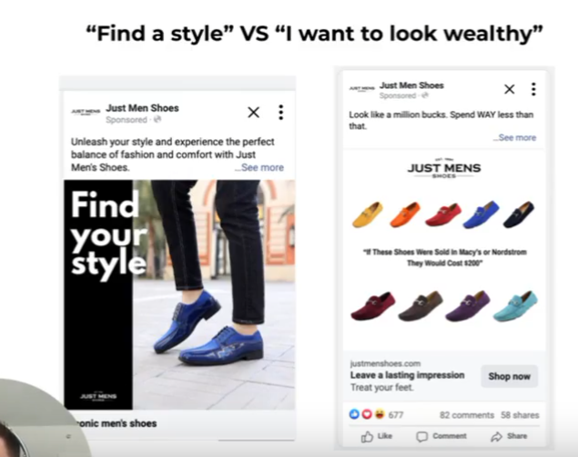

Market Sophistication:

Lesson Example:
- When all of the products look the same, there is no clear or obvious choice… They all seem to be the same, so you just pick one
- But when a well-branded or new mechanism/product is introduced, it automatically grabs attention and becomes the more attractive choice

What Is Market Sophistication:
- Market sophistication is the level of knowledge your market has of your product/services
- How many similar products has your market been told about before?
- How many similar products have they tried before 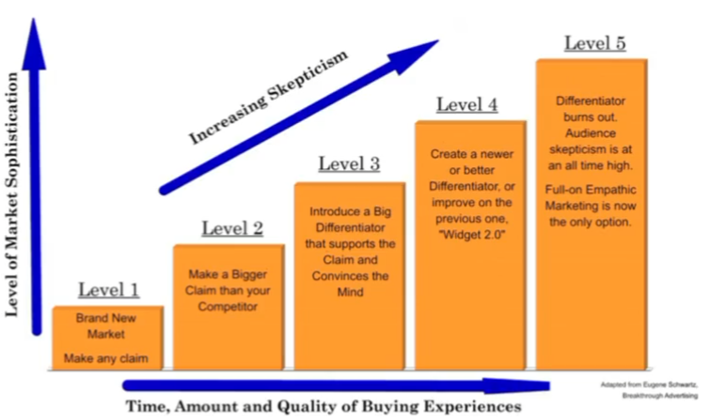

Market Sophistication Stages:
- Stage 1:
  - Definition:
    - First to market, aka the Market has never seen your product
  - Goal:
    - Be simple, Be Direct
  - Action:
    - Name the claim and prove it works

- Stage 2:
  - Definition:
    - Market is starting to see it
  - Goal:
    - Enlarge the successful claim of competitors and one-up your competitors
  - Action:
    - Make bigger and stronger claims.

- Stage 3:
  - Definition:
    - Market Has Hear All The Claims
  - Goal:
    - Introduce a new mechanism
  - Action:
    - Focus on HOW the product delivers the SAME claim in a NEW and better way

- Stage 4:
  - Definition:
    - Market Now Knows The Mechanisms
  - Goal:
    - Enlarging your mechanism
  - Action:
    - Make it easier, faster, solve it better, overcome limitations

- Stage 5:
  - Definition:
    - Market No Longer Believes You
  - Goal:
    - Focus your advertising on identification with your prospect
  - Action:
    - Show the market the version of themselves they want to become, selling the persona of using your products

How To Determine Market Sophistication:
- Analyze your product and the problems it solves
- Identify all of the competitors selling the same product
- Identify all of the businesses solving the same problem

- Create a Market Sophistication Foreplay board
  - During competitor research, leverage foreplay to build your own “Boxes” and see which ones resonate with you and how you can attack an angle that the market has not seen before

How To Find Winning Products:

Myth-Busting:
- There is no “Winning Product.” Any Product can be a “Winner”
- Spam Test Is BS
  - If your spam testing is relying on LUCK
- Instant Success
  - Gurus tell you success is immediate, but building a brand takes time and persistence

Mindset: What To Expect:
- Expect To Fail
  - Realistically, when you first start testing, you’re going to suck
  - The more reps, the better you get
- Chase High Intent Reps, Not Perfection
  - Most beginners don’t make it in Ecom because they try to be perfect
- Intent - Track Everything You Do
  - Track every product and creative you test, and list why you want to test
- Feedback Loops
  - As long as you keep testing, you are guaranteed to succeed
  - The more you succeed, the easier it will become to succeed
- Success
  - As you start to learn and get better, you put in enough hours, and your product hit rate goes up
  - Success may take longer than you think, but if you continue, it is guaranteed

Product Criteria:
- AOV and profit margin
  - Aim for an AOV of $60+ after bundles to ensure profitability
  - Min 3x COGS + Shipping, ideally more. This will give you a huge advantage in scaling
- Trend Awareness
  - Keep an eye on emerging trends
  - Do a quick Google Trends search on the niche and trend. Make sure it’s not trending down
- Product Weight
  - Avoid heavy items
  - Shoebox Rule

What Even Is A Winning Product?:
- A winning product is a product that satisfies a mass desire
- Any product can work, but some will be more difficult than others

What Affects How Easy and Hard It Is To Make A Product Work:
- Magnitude Of Desire
  - Weak Desire Example: I’d like my desk to look more organized
    - Desktop organizers ($15-$30)
    - Cable management clips ($10)
    - Decorative pen holders ($20)
  - Strong Desire Example: I need to lose 30 pounds before my wedding in 3 months
    - High-ticket weight loss coaching ($2000-$5000)
    - Specialty meal delivery services ($300-$500/month)
    - Personal Training ($1000-$3000)
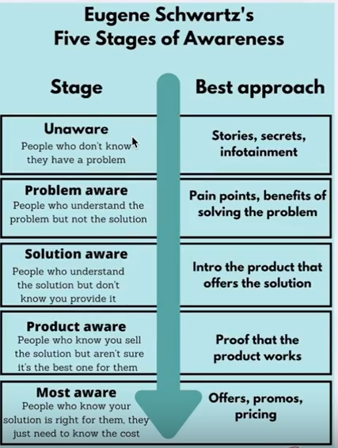
    - Medical weight loss procedures ($5000-$15000)

How Do You Deal With Competition/Saturation?
- Saturation = Big audience. Don’t Be Afraid Of Competition
  - This is the PITFALL of most of the copy-paste gurus
- You Don’t Have To Start With Stock Or Customized Product
  - Starting out, it’s a bad idea to buy upfront stock
- 2 Ways You Can Stand Out
  - Either innovate the product
    - Either you have a new product/mechanism that solves an existing problem better
  - Or innovate on the avatar
    - Target an underserved avatar

You Don’t Need An Untapped Market Or Game-Changing Desire To Win:
- Case Study 1: Shilajit (New Mechanism)
  - A year or two ago, when Shilajit was just in the resin form, it was a bunch of Level 1 and Level 2 sophistication claims
    - Brands came in with a new form of delivery (mechanism) to reset sophistication
    - Other solutions to succeed would be framing the product as “Ours Is The Best Due To These Lab Test”
- Case Study 2: Stanley (New Avatar)
  - Stanley Cups were originally made for construction workers to keep their drinks hot.
    - Sophistication reset
      - Originally an old Market (Stage 5) (Construction Workers)
        - “Keeps ice 2 hours longer than YETI
        - “Double-wall vacuum insulation with proper lining”
      - New Market (Stage 1) (Gen Z)
        - “Your emotional support water bottle”
        - “The cup that makes you drink more water.”

- Case Study 3: TrueClassic (New Avatar + Mechanism)
  - All the other brands were targeting hypebeast (Supreme), gymbros (Gymshark), bargain hunters (Hanes) and athletic dudes (Cutts). TrueClassic targeted an underserved avatar, the “Dad Bod” (Age 30-55)
    - Traditional T-shirt marketing
      - “Athletic fit” (Bad For Dad Bods)
      - Models With 6 Packs
      - Brand Hype
    - TrueClassic’s Avatar-Specific Marketing:
      - Regular guys with realistic bodies
      - “Before/after” in the same moment (Just changing shirts)
      - Relates to the Avatar
    - Traditional T-Shirt Claims (Stage 5)
      - Everyone Claiming “Softest,” “Highest Quality,” “Best Fit”
    - TrueClassic’s Claims:
      - First to acknowledge this avatar exists
      - First to offer a solution
      - No competition speaking to this pain point
    - Mechanism Innovation:
      - Body-optimizing fit (Hides gut, enhances shoulders)

It All Comes Back To Understanding The Customer:
